Task No 01: Complete the following tasks:

1. Create Database named as Information.

Solution:

create database Information;

Output:

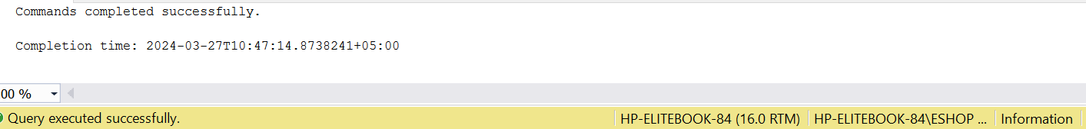

1. Using Database Information create Employee table based on the following design:

Solution:

create table Employee(empno decimal (4, 0) not null primary key, ename varchar (10) not null, job varchar (9), mgr decimal (4, 0), hiredate date);

Output:

1. Modify Employee table and add three more columns:

Solution:

Alter table Employee add sal money not null, comm money not null, deptno decimal (2, 0) not null;

Output:

1. Insert 5 records in Employee Table.

Solution:

Alter table Employee add sal money not null, comm money not null, deptno decimal (2, 0) not null;

Output:

1. Delete all records from Employee table.

Solution:

Alter table Employee add sal money not null, comm money not null, deptno decimal (2, 0) not null;

Output:

1. Drop Employee table.

Solution:

Alter table Employee add sal money not null, comm money not null, deptno decimal (2, 0) not null;

Output:

1. Drop Database Information.

Solution:

Alter table Employee add sal money not null, comm money not null, deptno decimal (2, 0) not null;

Output:

Solution:

use Northwind;

select OrderID, ProductID, UnitPrice from [Order Details]

Output:

Task No 02: Create a database for an online bookstore. In the database create the table will store information about books available for sale. Each book has a unique ISBN (International Standard Book Number), a title, an author, a genre, and a price.

Solution:

CREATE DATABASE OnlineBookstore;

USE OnlineBookstore;

CREATE TABLE Books (

ISBN VARCHAR(20) PRIMARY KEY,

Title VARCHAR(255) NOT NULL,

Author VARCHAR(100) NOT NULL,

Genre VARCHAR(50),

Price DECIMAL(10, 2) NOT NULL

);

Output:

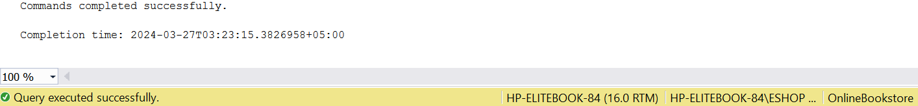

Task No 03: Design a database for a small company to manage its employees. You need to create a table to store employee details, including their employee ID, name, department, position, and salary.

Solution:

CREATE DATABASE CompanyManagement;

USE CompanyManagement;

CREATE TABLE Employees (

EmployeeID INT PRIMARY KEY IDENTITY(1,1),

Name VARCHAR(100) NOT NULL,

Department VARCHAR(50) NOT NULL,

Position VARCHAR(50) NOT NULL,

Salary DECIMAL(10, 2) NOT NULL

);

Output:

Task No 04: Design a CRM database schema with tables for customers, orders, and products. Include fields for CustomerID, Name, Email, and Phone in the customer table. Define fields like OrderID, CustomerID (referencing Customers), OrderDate, and TotalAmount in the orders table. In the product table, include ProductID, Name, Description, and Price. Establish relationships between tables to streamline customer interactions, order processing, and product sales management in the CRM system.

Solution:

CREATE DATABASE CRMDatabase;

USE CRMDatabase;

CREATE TABLE Customers (

CustomerID INT PRIMARY KEY,

Name VARCHAR(100) NOT NULL,

Email VARCHAR(255) NOT NULL,

Phone VARCHAR(20) NOT NULL

);

CREATE TABLE Orders (

OrderID INT PRIMARY KEY,

CustomerID INT,

OrderDate DATE,

TotalAmount DECIMAL(10, 2),

FOREIGN KEY (CustomerID) REFERENCES Customers(CustomerID)

);

CREATE TABLE Products (

ProductID INT PRIMARY KEY,

Name VARCHAR(100) NOT NULL,

Description TEXT,

Price DECIMAL(10, 2) NOT NULL

);

Output:

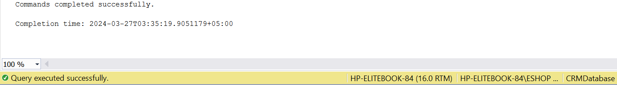

Task No 05: Create the following tables given in diagram with constraints.

Solution:

use Northwind;

select OrderID, ProductID, UnitPrice from [Order Details]

Output: